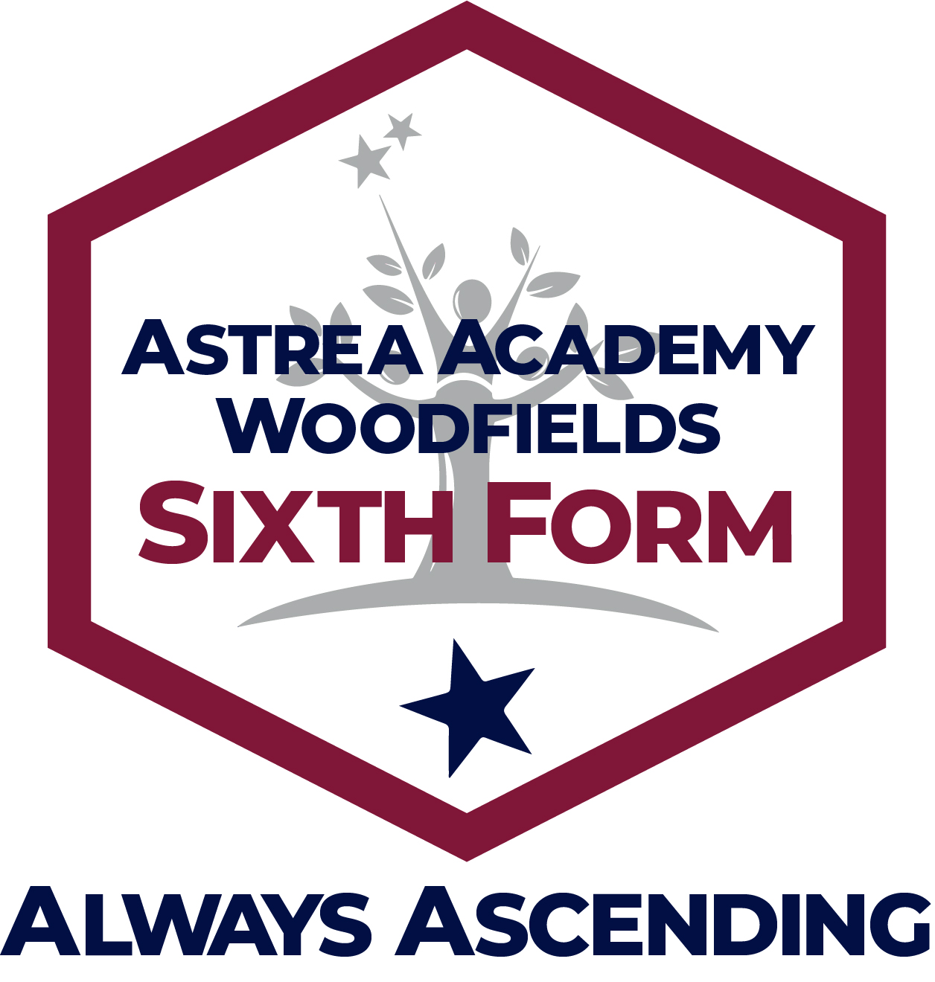
Sixth Form Application
Section 1: Personal information
Name of student: |  |  | Home Tel:
Address: |  |  | Mobile:
 |  |  | Email:
 |  |  | Previous school:
 |  |  | Referee Name:
 |  |  | Referee Tel:
Post Code: |  |  | Referee Email:
Emergency contact details

First contact: |  |  | Second Contact:
Name: |  |  | Name:
Mobile: |  |  | Mobile:
Address: |  |  | Address:
Email: |  |  | Email:
Relationship to student: |  |  | Relationship to student:
Personal Information: We would like to know as much as possible about you; your interests and other activities. Please tell us about yourself, including any jobs, training schemes, extracurricular activities and why you want to join our Sixth Form.
Career Aspirations: We would like to know about your career aspirations and the education or employment pathway you would (currently) like to take.

Section 2: Education
Please complete this table with your current predicted grades for the summer 2020 exam series. Please include all GCSE and BTEC qualifications you are currently entered for. Note that our standard entry requirements refer to actual grades from the summer 2020 exam series. An offer of a place is conditional upon actual grades.
For reference, our standard entry requirements for our Sixth Form are a Grade 4 or above in GCSE English Language and Mathematics and an average point score (APS) of 4.0 from GCSE/BTEC qualifications. Specific courses may have their own entry requirements above this.
Students who achieve a Grade 3 in English Language and/or Mathematics and achieve an average point score (APS) of 3.0-3.9 may also be able to join our Sixth Form. In both instances students should discuss this with the Sixth Form team.
Qualifications table
Subject: | Type of qualification | Level | Exam board | Predicted grade | Actual grade  (if known)
English Language | GCSE | 2
English Literature | GCSE | 2
Mathematics | GCSE | 2

Section 3: Choices
Please select which courses and qualifications you would like to study at our Sixth Form. We aim to run all of the courses and qualifications in the core and optional curriculum. However, the viability of each is based on numbers of students studying. We reserve the right to withdraw or amend courses and qualifications.
Core Curriculum: Courses / Qualifications on offer 2020/21
- You must choose a major course from Block A and may choose a minor choice from Block B. If you require a re-sit in GCSE English and/or Mathematics, this will take place in Block B.
Block A, Major course (3-size), you must choose one qualification
Route | Qualification | Tick
1 (level 3 study) | BTEC National (Extended Diploma) Sport
 | BTEC National (Extended Diploma) Sport & Exercise Science
 | BTEC National (Extended Diploma) Health & Social Care
2 (level 2 study) | BTEC Technical Diploma for Sport & Activity Leaders

Block B, Minor course (1-size), you may choose one course
Route | Qualification | Tick
1 (level 3 study) | BTEC National (Extended Certificate) Applied Science
 | NCFE VCert Child Development and Care (level 2)
2 (level 2 study) | Re-sit GCSE English*
 | Re-sit GCSE Mathematics*
*Only tick this box if you have not / or may not achieve a grade 4 in GCSE English Language or Mathematics
Block D, Enrichment, you may choose an enrichment specialism if on a Sport qualification
Enrichment | Tick
Football – see prospectus for more details
Sports Medicine – see prospectus for more details
Coaching and Teaching – see prospectus for more details
Extended Project Qualification (EPQ)

Optional Curriculum: Courses / Qualifications on offer 2020/21
- You may choose courses and qualifications from the optional curriculum. Tick those that you are interested in. Course/qualification costs can be discussed with the Sixth Form team.
Qualification | Tick
Sports Massage Therapy (Level 4 diploma)
Personal Training (Level 3 Certificate)
Exercise Referral (Level 3 Diploma)
Sports Massage Therapy (Level 3 Diploma)
Gym Instructing (Level 2 Certificate)

Section 4: References
Please provide two referees who could support your application to our Sixth Form. This may be your current Head of Year or Form Tutor.
Name: | Name:
Role: | Role:
Address: | Address:
Email address: | Email address:
Contact number: | Contact number:

Section 5: Submission
Please return your completed application to:
Miss Bain,
Head of Sixth Form
Astrea Academy Woodfields
Weston Road
Doncaster
DN4 8ND

Office use only:
Application received on |  | Unconditional offer
Added to database |  | Conditional offer
Confirmation letter sent |  | Advised Interview letter sent
Attendance % |  | Date of interview
Reference received |  | Interview attended
Notes from application form/reference:
Notes from interview:

